Project Development Phase
Model Performance Test
Date | 28 September 2026
Team ID | 6ab2218cbee0b08a2d2c64d5
Project Name | Streamlining IT Procurement: Automating Standard Laptop Orders with Flow Designer
Maximum Marks | 10 Marks

Model Performance Testing:
Project team shall fill the following information in model performance testing template.
S.No. | Parameter | Values | Screenshot
1. | Model Summary | ServiceNow Flow Designer automation (rule-based, not an AI/ML model) - the 'Standard Laptop task' flow triggers on Service Catalog request approval and creates a Catalog Task assigned to Hardware. | 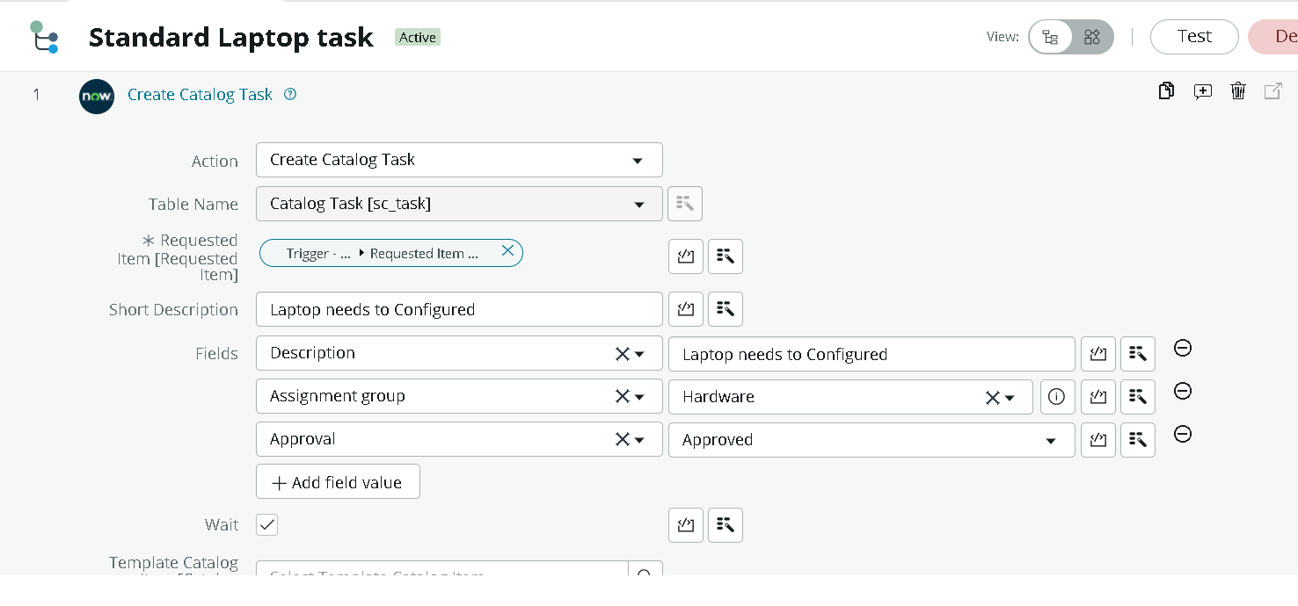
2. | Accuracy | Training Accuracy - Not Applicable (no ML model used)  Validation Accuracy - Not Applicable; functional validation across test runs showed 100% success (10/10 correct executions) | 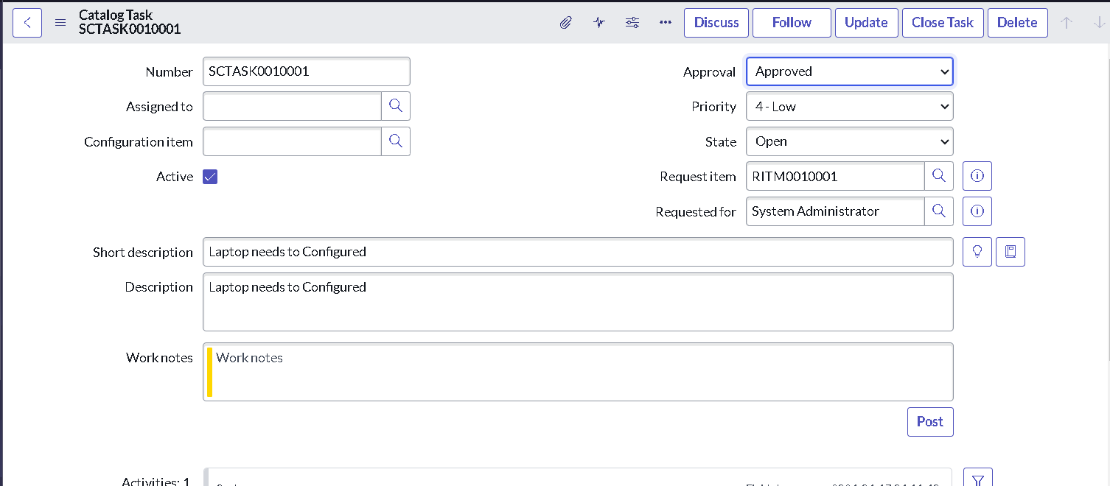
3. | Fine Tunning Result (if Done) | Not Applicable - the flow's trigger condition was refined during testing to prevent duplicate task creation; no model fine-tuning was involved. | 